TUBERCULOSIS CASE INVESTIGATION PROTOCOL

1. Case, case contacts and epidemic investigation aims

Single case investigation aims
The infectiousness of each tuberculosis case is necessarily assessed, i.e. the risk that the patient will transmit (or has transmitted) the disease to other people. For this purpose, apart from collecting information about the characteristics of the patient’s disease, information is also collected regarding the patient’s activities and social environment. This information itself leads to the next step of the investigation, which is the investigation of the case contacts. For this reason, the continuous aim is to ensure the patient’s cooperation and the creation of a climate of trust.

Case contacts investigation aims
The contacts have to be investigated in all instances of tuberculosis cases, which entail a risk of transmitting the disease to other people. The aim is to actively search for all the people who have had high-risk contacts (regular, close and prolonged) with the patient, and to examine them in order to detect latent tuberculosis infection or active tuberculosis and administer chemoprevention or full anti-tuberculosis treatment. This aims at protecting these people’s health, but also at breaking the tuberculosis transmission chain, so that public health is protected.

Epidemic investigation aims
A tuberculosis epidemic is the appearance of two or more cases of the disease, which are not directly related to each other, in the same social, professional or other environment. This fact suggests that tuberculosis has been widely transmitted in a particular place. Therefore, an epidemic investigation primarily aims at breaking the transmission chain, and, if possible, detecting the original source of infection in order to prevent a new transmission in the future. As for the remainder, the same principles that govern the contacts investigation are applied on a greater scale and by taking into consideration the special characteristics of every environment.
Some places possess characteristics that favor the spread and the infection of M. tuberculosis, sometimes in combination with the presence of susceptible people who are more likely to become ill with active tuberculosis. These cases require special handling, even in the instance of a single case, in order to prevent an epidemic outbreak.

Case, case contacts and epidemic investigation
2.1 Single case investigation
In order to fully assess the infectiousness of a tuberculosis case, information on the characteristics of the disease is required:
- Anatomic detection of the disease (pulmonary / extrapulmonary)
- The patient’s symptoms (e.g. cough, haemoptysis) and their start date
- Imaging test results (mainly chest X-ray)
- Laboratory test results (and information on the samples which have been sent to the laboratory and whose results are expected to be received)
- Anamnesis of previous tuberculosis disease and previous administration of anti-tuberculosis treatment
- Anamnesis of a chronic disease or other chronic health problems (e.g. alcoholism, substance use)
- Anamnesis of infection of the HIV virus
The physician can gather most of this information.
In the case that the characteristics of the disease do not suggest a risk of transmission to other people (extrapulmonary tuberculosis), no further investigation is required. Exceptionally, investigation may be recommended in some cases in order to detect the source of infection, especially when the patient is a child, who has probably been recently infected by an adult (see 4.2 ‘Investigation of the source of infection’).
Contrarily, when there is a risk of transmission to other people (in all the cases of pulmonary or laryngeal detection, or tuberculous pleural effusion), the transmission period has to be defined. This usually begins when the patient’s first symptoms occur or three months before diagnosis.
Moreover, further information has to be collected so that, contacts are subsequently investigated:
- Contact details (address, telephone number) of the patient and possibly of their immediate family;
information about the environment in which the patient was active (working, social, familial), where there are probably people who have come into close contact with the patient;
- An initial list of the people who came into close contact with the patient during the estimated transmission period, including their contact details.
This information is collected by patients themselves and is very important, especially with regard to the symptoms and the patients’ environment. Therefore, it is necessary to create a climate of trust and cooperation, in order for the obtained information to be trustworthy.
In this framework, the public health official should give the patient the opportunity to ask any questions they have about the disease and the subsequent investigation steps, and these questions should be clearly answered. Discretion and respect for the patient’s wishes are required, as tuberculosis is a disease that still carries a social stigma. Moreover, the patient has to be ensured regarding confidentiality, which is always in balance with the need for public health protection.
References:
- Centers for Disease Control and Prevention. Guidelines for the investigation of contacts of Persons with Infectious Tuberculosis - Recommendations from the National Tuberculosis Controllers Association and CDC. ΜMWR 2005;54(No. RR-15)
- Public Health Agency of Canada. Canadian Tuberculosis Standards, 2007.

Case contacts investigation
Contacts investigation is a main tool for the protection of public health against tuberculosis. Contacts must be investigated in all instances of tuberculosis cases when there is a risk of transmission to other people, i.e. in all instances of pulmonary or laryngeal tuberculosis cases. Priority is given to the investigations of contacts in which:
- The case presents increased contagiousness (i.e. with positive microscopic examination of sputum, positive sputum culture or a cavern in the chest X-ray).
- The case was not diagnosed for a long period of time (long period of contagiousness).
- A big number of contacts or quite vulnerable people are involved (who are more likely to become ill with active tuberculosis if they are infected, such as children and immunosuppressed people).
The first step of the investigation is the examination of the case environment and the detection of the people with whom the patient came into contact during the period of contagiousness (case contacts). A person’s environment can be divided in three parts: the familial environment, the school or working environment and the wider social environment. In these places, the case comes into regular, close and prolonged contact with some people, and it comes into less close contact with other people. These are depicted in image 1.
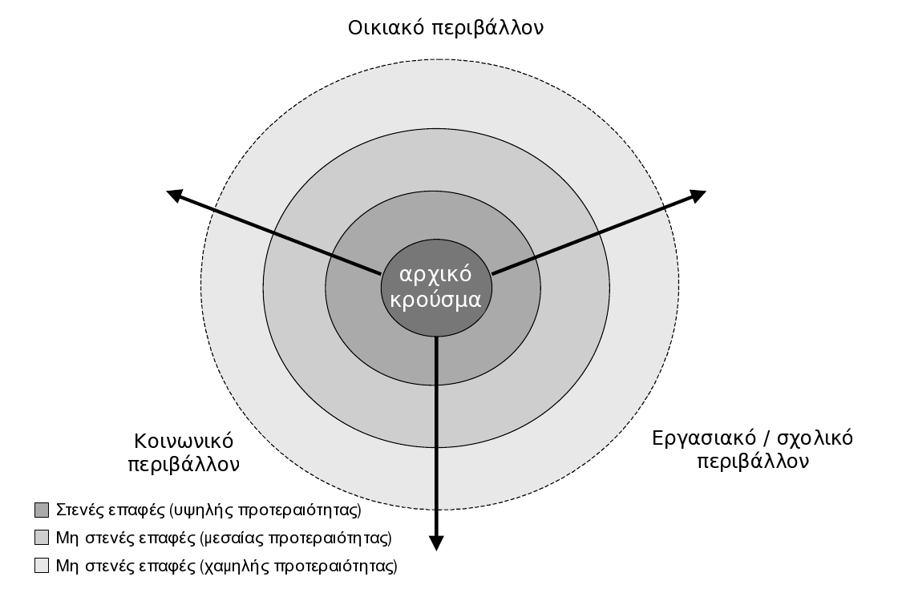

The investigation is led by the information given by the patient regarding their environment and contacts. Subsequently, the public health official thoroughly researches all the case contacts in these three directions. The places where the infection possibly occurred are also important; often, a visit to these places (e.g. to the patient’s house) may reveal characteristics of theirs, which favor transmission, as well as contacts that were not initially detected.
Then, each contact undergoes a test in order to assess whether they suffer from active tuberculosis (in which case they have to receive full anti-tuberculosis treatment), or if they have latent tuberculosis infection (in which case they have to receive chemoprevention treatment). Unfortunately, up to now there is no single, simple and reliable screening test that separates the people who have been recently infected with M. tuberculosis from the people who have not been infected.
The initial risk assessment of each contact is probabilistic, and takes into consideration:
- The possibilities of infection, based on exposure to the case.
- A person’s vulnerability to the infection and to the disease, i.e. the possibility of becoming ill with active tuberculosis after infection.
In this way, the case contacts are categorized into high-risk, medium-risk and low-risk contacts and priority is accordingly given to their investigation. The following characteristics increase a contact’s risk:
Exposure to the case: This is a factor, which is difficult to quantify. The frequency and duration of contacts between the contact and the case plays an important role. Moreover, the place where the two people came into contact is significant; the more confined, closed and poorly ventilated a space, the greater the possibility of transmission.
Age: Children up to 5 years of age have a significantly higher risk of becoming ill with active tuberculosis if they are infected, with a shorter incubation period. Moreover, they are more likely to suffer from more serious forms of the disease (such as tubercular meningitis), even though they do not usually transmit the disease themselves, but, on the contrary, are infected by adults who are in their environment.
Immunosuppression: The administration of cortisone, immunosuppressants (such as anti-TNFα agents) or chemotherapeutic substances, and the infection with the HIV virus, significantly increase the risk of active tuberculosis outbreak after an infection with M. tuberculosis. HIV-infected people, in particular, may become ill with active tuberculosis very quickly, with an atypical clinical and radiological appearance; therefore they require special attention. HIV testing should be provided to all those who are suspected of being infected.
Other conditions: Malnutrition and low body weight, alcoholism, diabetes mellitus, chronic renal insufficiency and intestinal malabsorption syndromes are conditions, which, increase a contact’s vulnerability to the infection and to the disease.
The process of testing each case contact includes the following:
- Medical history taking:
  - Assessment of the risk (possibility of infection and vulnerability to the infection)
  - Questions about tuberculosis symptoms (cough, haemoptysis, weight loss)
- Mantoux test (or IGRA)
- Chest X-ray (if necessary)
The Mantoux test is done during the initial assessment. If the result is negative and if less than 8 weeks have passed since the person’s last contact with the case, the test is repeated when the period of 8 weeks has elapsed. This is the maximum time required for the Mantoux test to produce positive results after an infection with M. tuberculosis. The test result is assessed according to the possibility of infection and the person’s vulnerability to the infection, by using different boundaries for the reaction diameter, measured in millimeters (see table 1). The test is also taken in order to cover the possibility of alteration (increase >10mm) in comparison to a previous Mantoux test.
IGRA testing, if available, can be used alternatively or additionally, especially in cases where the positive result of the Mantoux test it doubtful, for example due to previous vaccination with BCG. However, it is highlighted that there is not wide experience regarding the use of IGRA in children, immunosuppressed people and people who have been recently exposed to the mycobacterium.
If the result of the Mantoux test (or of the IGRA) is positive, or if there are any suspicious symptoms (cough, haemoptysis, weight loss), a chest X-ray must be taken in order to exclude the possibility of active tuberculosis. Full anti-tuberculosis treatment is administered to those who become ill with the disease. If the X-ray is negative, the possibility of chemoprevention is considered (see section 5.2 ‘Precautionary measures’). Under no circumstances should chemoprevention be administered if there is any clinical, radiographic or microbiological indication of active tuberculosis.
During the contacts investigation of a tuberculosis case, medium-priority and high-priority contacts are investigated first, according to their proximity to the case and their vulnerability. It may be decided to extend the investigation to cases of lower priority in one of the following cases:
- If an unexpectedly high percentage of tuberculosis infection or active tuberculosis is detected in the investigated contacts. This depends on the type of the investigated population and on its transfection rate, which should be normally defined by prevalence studies.
- If there are indications of secondary transmission, i.e. transmission from diseased case contacts to other (secondary) contacts.
- If there are indications of transmission or disease among contacts of lower priority.
In any case, high-priority contacts must be investigated before it is decided to extend the contacts investigation. In other words, the investigation follows the logic of concentric circles, as shown in image 1.The decision to extend the investigation to the next circle always takes into consideration the expected benefit (detection of contacts with latent tuberculosis infection or active tuberculosis) in relation to the available resources. Additionally, the more we walk away from the initial case, the higher the possibility of a false-positive Mantoux test result among the people who are investigated. In the case of a lack of resources, both human and material, assistance is sought from a larger health organization.
The case investigation is completed when there are no more reasons to extend it, when all the suspicious case contacts have been detected and investigated, and when the treatment of the people who suffer from active tuberculosis or latent tuberculosis infection is underway.

Investigation of the source of infection
Children up to 10 years of age do not usually transmit tuberculosis to other people, and they are infected by diseased adults who are in their environment (usually in the familial environment). Therefore, there is no point in investigating the contacts of a child who is ill with the disease, but it is important to search for the adult who constituted the source of infection, in order to investigate their contacts. This reverse process is called investigation of the source of infection: people who display tuberculosis symptoms are sought in the environment of the case (i.e. of the child), and they take a Mantoux test and a chest X-ray. The relevant information is usually obtained from the child’s parents or guardians.
The success of an investigation of the infection source depends on the time when a person was infected. A diseased adult may have been infected with M. tuberculosis many years ago, therefore it is practically impossible to detect the source of the infection. Children, however, and especially very young children (up to 5 years of age), have been recently infected; usually, the adult who constitutes the infection source is still in the child’s environment and therefore he or she can be identified and receive anti-tuberculosis treatment in order for the transmission chain to break.
However, the investigations of an infection source are generally not very effective in comparison to the effort they require; therefore in most cases they are recommended only when there are large resources and when the high-priority contacts investigations are successfully conducted.

Epidemic investigation
..............................

Schools and educational institutions
........................................

Reformatory stations
...............................................................

Travel by aeroplane
.................................................

